**OSH AUTHORITIES – CROATIA**

Source: <https://oshwiki.eu/wiki/OSH_system_at_National_Level_-_Croatia>

* OSH Infrastructure

Scheme:

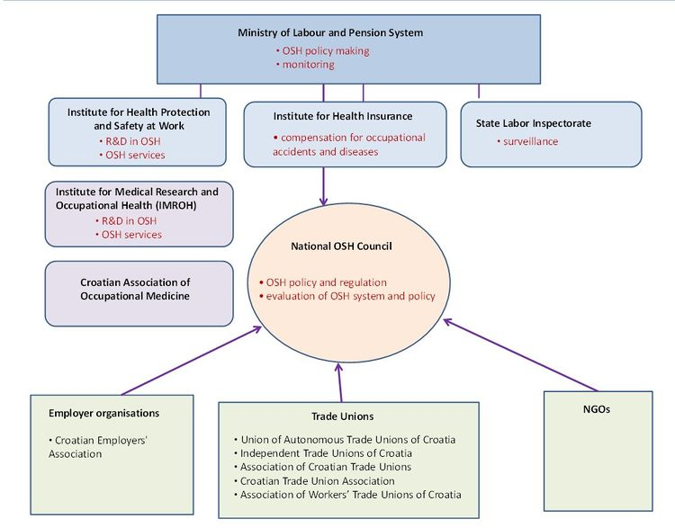

* OSH authorities and inspection services

|  |  |
| --- | --- |
| Name of the Authority | Ministry of Labour and Pension System |
| Link | <http://www.mrms.hr> |
| Short abstract | The mandate of the Ministry of Labour and Pension System includes drafting legislation, monitoring OSH, making suggestions for campaigns to raise awareness, and organizing activities to promote OSH. |
| Link to OSH wiki | <https://oshwiki.eu/wiki/OSH_system_at_National_Level_-_Croatia> |

|  |  |
| --- | --- |
| Name of the Authority | The State Labour Inspectorate |
| Link | <http://www.inspektorat.hr/> |
| Short abstract | The State Labour Inspectorate is a government organization. It is responsible for enforcing OSH legislation and performing inspections. There are 42 branches in five headquarters, corresponding to the administrative centres of Osijek, Rijeka, Split, Varazdin, and Zagreb. Each has an OSH Department and a Labour Department. OSH inspectors are in charge of first degree inspections in trade and crafts, mining, the energy sector, vessels under pressure, catering and tourism. Inspectors working in OSH Departments are tasked with the second degree procedures. |
| Link to OSH wiki | <https://oshwiki.eu/wiki/OSH_system_at_National_Level_-_Croatia> |

Internal link to enforcement indicator by MS

* Compensation and insurance bodies

|  |  |
| --- | --- |
| Name of the Body | Croatian Institute for Health Insurance |
| Link | <http://www.hzzo-net.hr/> |
| Short abstract | The Croatian Institute for Health Insurance (Hrvatski zavod za zdravstveno osiguranje) is the administrative body for general health insurance, including industrial accident insurance under the ministerial responsibility of the Ministry of Health. From 2006-2010, the Croatian Institute for Occupational Health Insurance was responsible for the allocation of funds for prevention activities, diagnosis and treatment for occupational diseases and accidents, and sick leave compensation. These tasks have been performed by the Croatian Institute for Health Insurance since 2011. |
| Link to OSH wiki | <https://oshwiki.eu/wiki/OSH_system_at_National_Level_-_Croatia> |

|  |  |
| --- | --- |
| Name of the Body | Croatian Pension Insurance Institute |
| Link | <http://www.mirovinsko.hr/> |
| Short abstract | The Croatian Pension Insurance Institute is a public institution established on the basis of the Pension Insurance Act which at the same time designated the commencement of the pension system reform aimed to providing for the mandatory pension insurance entitlements to the employees, farmers, craftsmen and others. The Institute is a legal successor of the former republic pension and invalidity insurance funds of workers, self-employed persons and farmers i.e. of all previous institutions. |
| Link to OSH wiki | <https://oshwiki.eu/wiki/OSH_system_at_National_Level_-_Croatia> |

* Research institutes

|  |  |
| --- | --- |
| Name of the Institute | Institute for Occupational Medicine and Medical Research (Zagreb) |
| Link | <https://www.imi.hr/en/> |
| Short abstract | The Institute for Medical Research and Occupational Health (IMROH) was established in 1947, originally as the Institute for Industrial Hygiene. Research started in 1949 studying the health impacts of physical and chemical workplace conditions. From 1953, the Institute expanded to include departments of oncology, immunochemistry, chemotherapy, balneology, climatology, and the history of medicine. IMROH applies a multi-disciplinary approach to studying how chemical, physical, and biological agents affect biological systems – in the general and working environment. This includes monitoring air, soil, water, and food, providing occupational health research, professional services, and expert advice to policy makers on environmental protection and safety at work. |
| Link to OSH wiki | <https://oshwiki.eu/wiki/OSH_system_at_National_Level_-_Croatia> |

* Prevention institutes

|  |  |
| --- | --- |
| Name of the Institute | Croatian Institute for Health Protection and Safety at Work |
| Link | <http://www.hzzzsr.hr/> |
| Short abstract | The Croatian Institute for Health Protection and Safety at Work (Hrvatski zavod za zaštitu zdravlja i sigurnost na radu) is a public institute under the ministerial responsibility of the Ministry of Health, responsible for implementing relevant legislation. Its main objective is to improve the quality of occupational health for all Croatian employees. To this end, CIOH is involved in defining measures for health protection, developing standards and working methods, as well as providing advice, supervision and training on occupational health protection. CIOH is the body responsible for maintaining registers and databases, (Reporting and monitoring occupational accidents and diseases in Europe | and collecting and analysing data on working conditions and occupational accidents and diseases) |
| Link to OSH wiki | <https://oshwiki.eu/wiki/OSH_system_at_National_Level_-_Croatia> |

* Other OSH services

|  |  |
| --- | --- |
| Name of the Service | Croatian Association of Occupational Therapists (H.U.R.T.) |
| Link | <http://www.hurt.hr/en/> |
| Short abstract | The Croatian Association of Occupational Therapists (H.U.R.T.) is a national, professional association which promotes interests of Occupational Therapists, ethics in occupational therapy profession and quality of occupational therapy services in the Republic of Croatia. |
| Link to OSH wiki | <https://oshwiki.eu/wiki/OSH_system_at_National_Level_-_Croatia> |

* Standardization bodies

|  |  |
| --- | --- |
| Name of the Body | Croatian Standards Institute |
| Link | <http://www.hzn.hr/> |
| Short abstract | The Croatian Standards Institute, the national standards body of the Republic of Croatia, is an autonomous non-profit public institution. It pursues the following objectives related to standardisation and certification:   * increasing the safety level of products and processes * protecting human health, lives and the environment * promoting the quality of products, processes and services * ensuring the appropriate use of work, materials and energy * improving production efficiency * controlling variety, ensuring compatibility and interchangeability * removing technical barriers to international trade. |
| Link to OSH wiki | <https://oshwiki.eu/wiki/OSH_system_at_National_Level_-_Croatia> |